Stata Code:

Table 2: regress v2x_polyarchy missingpromises loggede_gdp e_regionpol year loggede_wb_pop, cluster(country_id)

Table 3: regress v2regdur GDPgrowthannualpercent v2x_polyarchy missingpromises loggede_gdp e_regionpol year, cluster(country_id)

Table 3
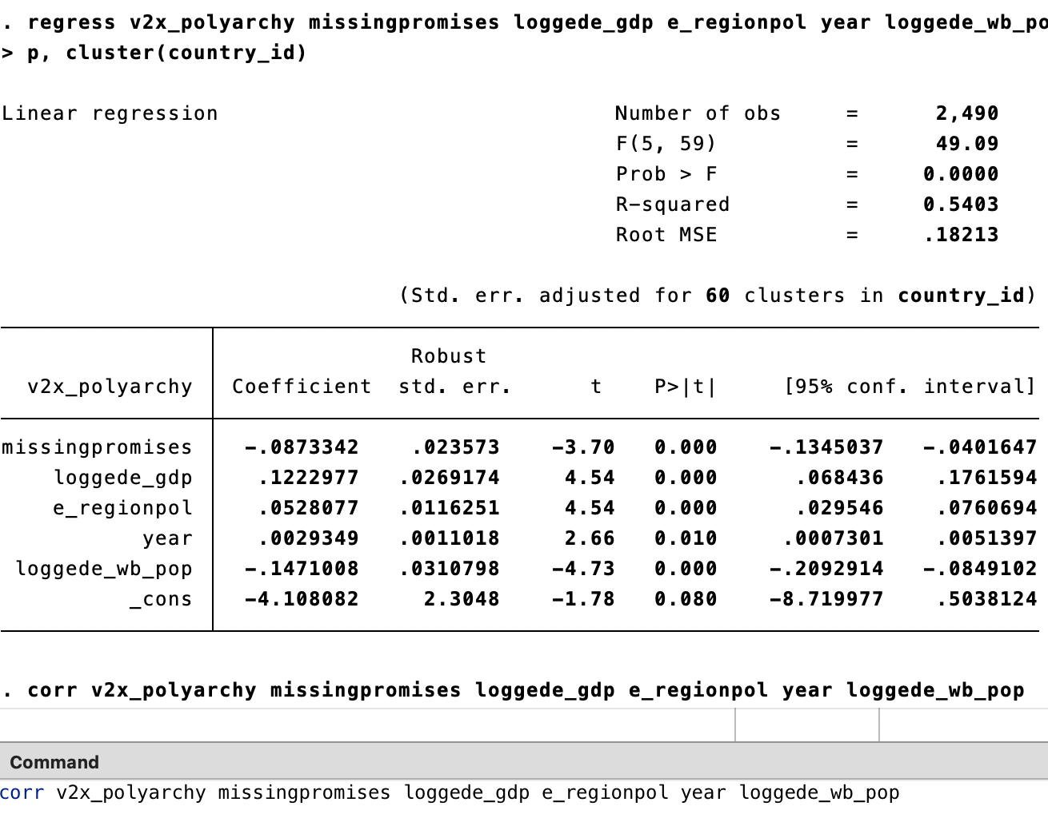
Table 4
